ASSIGNMENT WEBSITE

A restaurant website

Technology used

Html

Php

Sql

Xampp

Css

Javascript

The user has to register so that his/her data can be stored to the database

A registration page on a website is a form that allows users to create an account by providing their personal information. Typically, this includes details such as a username, password, email address, and any other relevant information the website requires. The registration process is a crucial aspect of user authentication and provides a way for users to establish a unique identity on the platform. Below, I'll explain the key components of a registration page and why user data is stored in a database.

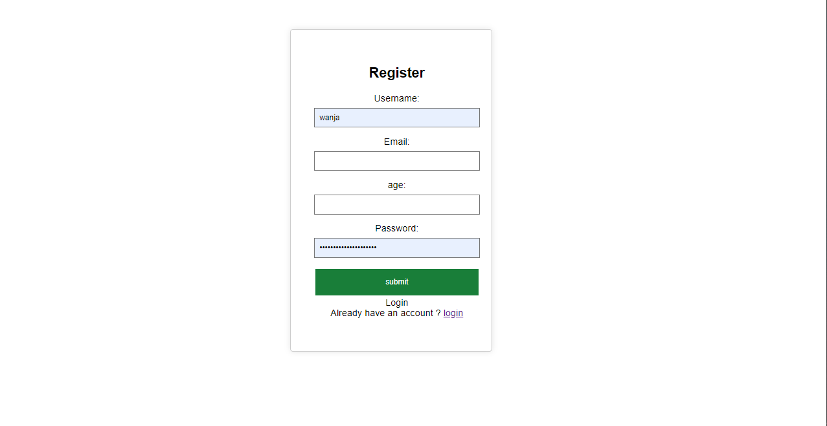

Login page

A login page on a website serves as the gateway for users to access their accounts by providing their credentials. It's a crucial component of user authentication and plays a key role in securing user accounts. Below, I'll explain the key components and importance of a login page. If the user have don’t have an account he/she has to register first



Home page

If the user has succesfuly login to the page he/she is able to go to the home page he/she can also log out of the



About age

An "About Us" page on a website is crucial for several reasons. It serves as a means to provide visitors with information about the organization, its mission, values, and the people behind it.





Contact page

A "Contact Us" page on a website is an essential component that serves various important functions. Here are key reasons highlighting

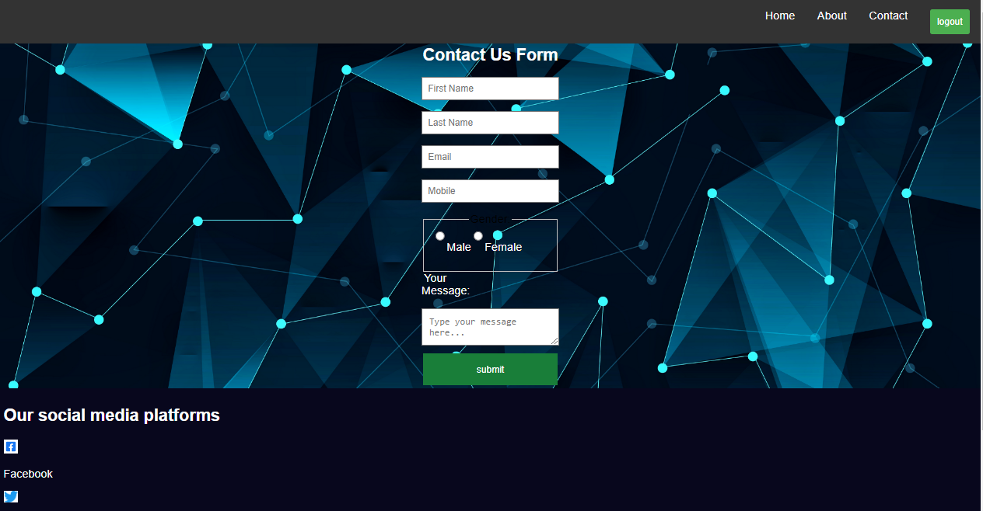

Database

A database is a critical component of many websites, providing a structured and efficient way to store, manage, and retrieve data. The details about a customer is stored in a database

